VPrivCal
  - A Brief Three-Option Preference-Elicitation and Awareness-Confirmation Method for User-Aligned Privacy Reminders in Vision-Language Assistants
Updated full research plan for egocentric VLM scenarios
Decision / research question
Can a brief three-option calibration improve immediate acceptance and privacy-cue awareness for standardized VLM reminders under controlled expert-verified detections?

Method at a glance
Element | Current design
Overall method | One rapid calibration method with two components: VPrivCal-Q10 and VPrivCal-Probe.
Component 1 | VPrivCal-Q10 initializes category and reminder-policy defaults.
Component 2 | Three egocentric scenes; participants point first, then review every verified category and choose one of three reminder-trigger thresholds.
Output | A transparent user-specific trigger policy with binary reminder output.
Primary evaluation | Generic versus Q10-only versus full VPrivCal on identical expert-verified held-out cues.
Primary outcomes | Immediate acceptance, privacy-cue awareness, binary alignment, false reminders, missed reminders, and burden.

Version 7 | July 2026 | Three-option trigger and controlled-evaluation edition

1. Executive summary
VPrivCal is a brief cold-start calibration method for egocentric VLM assistants. It asks ten direct policy questions, then uses three private, public, and semi-public scenes. Q1-Q6 and Probe use three trigger preferences: never remind, remind only when identifying or sensitive details are exposed, or remind whenever the expert-verified category is present.
The calibration is not the effectiveness outcome. Under a controlled locked cue set, VPrivCal is supported only if it improves immediate reminder-decision acceptance and privacy-cue awareness relative to the generic policy without increasing missed reminders.
Scope boundary
The first study concerns user-facing privacy reminders and pre-use intervention decisions in egocentric visual assistance. Long-term memory, external sharing, and delegated actions are excluded unless a later system version implements those behaviors.

2. Unified method architecture
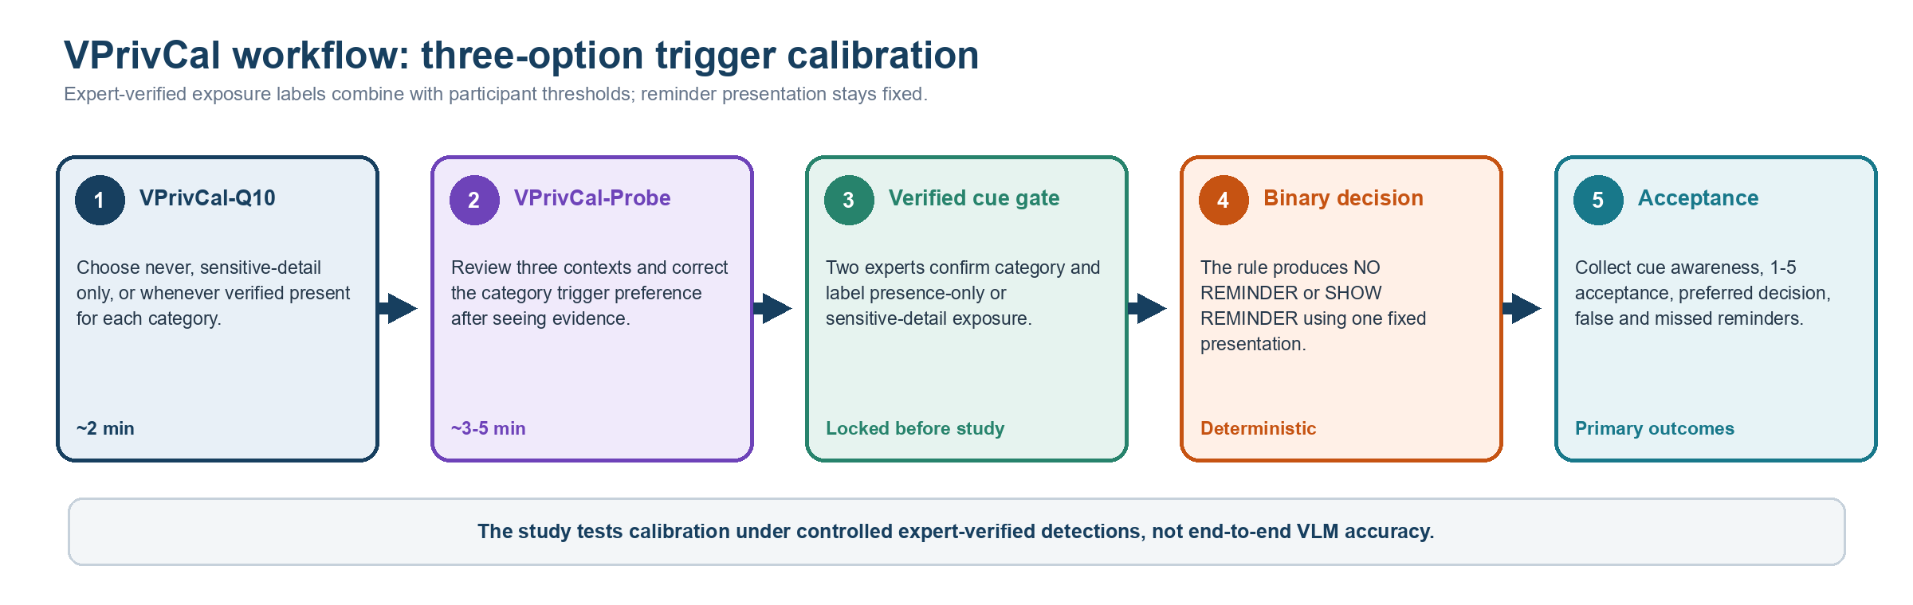
Figure 1. VPrivCal workflow. The two components belong to one method; policy effectiveness is assessed only on held-out video cases.
Component | Role | Signal
VPrivCal-Q10 | Rapid preference initialization | Six category defaults using the three-option trigger scale plus four cross-cutting settings.
VPrivCal-Probe | Contextual awareness confirmation and correction | Awareness status and preferred trigger for every category-image pair.
Policy layer | Transparent personalization | Weighted category priors and context corrections combined with locked exposure labels.
Held-out evaluation | Effectiveness test | Acceptance and awareness for binary reminder decisions on verified held-out cues.

3. Research questions and hypotheses
ID | Research question / hypothesis
RQ1 | Does full VPrivCal increase immediate reminder-decision acceptance over a generic policy?
RQ2 | Does full VPrivCal improve privacy-cue awareness without increasing missed reminders?
RQ3 | Does the sensitive-detail-only option produce distinct decisions for the two expert-confirmed exposure levels?
RQ4 | Does Probe improve trigger alignment beyond Q10 alone across categories and contexts?
H1 | Full VPrivCal will produce higher cue-level acceptance than the generic policy.
H2 | Full VPrivCal will preserve or improve cue awareness while reducing unwanted reminders.
H3 | Trigger alignment will be higher when held-out exposure level matches the participant's selected threshold.

4. VPrivCal-Q10: rapid preference initialization
Q1-Q6 retain the six high-level visual privacy categories used in the project. To reduce repetition and leading wording, the system presents one shared question and response scale, then shows the six categories one by one.
Shared question for Q1-Q6
When this type of information appears, when should the assistant show a privacy reminder?
1 Do not show reminders for this category | 2 Show reminders only when identifying or sensitive details are exposed | 3 Show reminders whenever this verified category is present

Item | Category | Examples | Policy parameter
Q1 | Biometric data | Faces, fingerprints, and other distinctive body features that may identify a person. | biometric_data_action
Q2 | Children images | Children, school events, playgrounds, and child-related activities. | children_images_action
Q3 | Personally identifiable information (PII) | Financial or medical data; names, passports, email addresses, phone numbers, GPS, license plates, and other identifiers. | pii_action
Q4 | Legal sensitivity information | Nudity or explicit imagery; violent or unlawful acts; criminal acts; weapons or other high-risk items. | legal_sensitivity_action
Q5 | Personal life | Home interiors, personal items, location context, landmarks, routines, relationships, and activities. | personal_life_action
Q6 | Background individuals | Passersby, bystanders, coworkers, patients, patrons, and other people incidentally captured. | background_individuals_action

4.1 Cross-cutting reminder-policy questions
Item | Dimension | Direct policy question | Parameter
Q7 | Inferred risks | When an expert-verified cue supports a sensitive inference, should the assistant show a reminder? | inference_reminder_level
Q8 | Other verified privacy categories | If experts verify a privacy category not covered above, when should the assistant show a reminder? | unlisted_category_trigger
Q9 | Uncertainty | When the VLM is uncertain about an expert-confirmed privacy cue, should the assistant show a reminder? | uncertain_risk_action
Q10 | Task relevance | When verified privacy-sensitive content is not needed for the current task, should the assistant show a reminder? | task_irrelevant_action

Timing target
The engineering target is a median completion time of about two minutes for Q10. Pilot readiness should require a median below three minutes, fewer than 5% skipped items, and no recurring comprehension error.

5. VPrivCal-Probe: three-scene, category-complete calibration
The revised Probe removes the active baseline VLM task and does not restrict each image to two cues. Each scene begins with an unmarked image. Participants first click or tap any specific content they think the assistant should handle carefully. The interface maps the selected region to one or more researcher-verified detections and automatically proposes a category, which the participant can correct. After this unprompted pointing phase, the system reviews every predefined high-level category present in that scene, highlights the linked evidence, and asks two compact questions. This design preserves an initial awareness signal while achieving complete category coverage across the three scenarios.
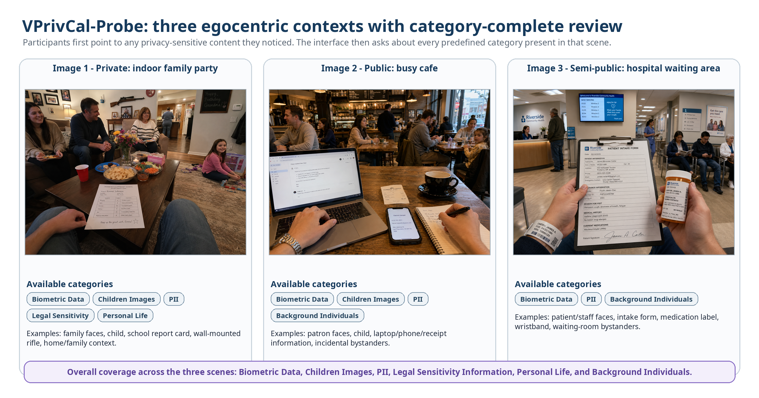
Figure 2. Revised VPrivCal-Probe stimuli. The set spans a private home party, a public cafe, and a semi-public hospital waiting area. Participants review all categories available in each scene; together, the three images cover all six high-level visual privacy categories.

5.1 Scenario coverage and category completeness
Scene | Scenario context | Available high-level categories | Representative evidence
1. Private - indoor family party | A first-person view during a family birthday gathering inside a home. | Biometric Data; Children Images; PII; Legal Sensitivity Information; Personal Life. | Family faces, an identifiable child, a school report card, a wall-mounted rifle, family photographs, toys, and home/family context.
2. Public - busy cafe | A first-person view while using a laptop and writing notes in a crowded cafe. | Biometric Data; Children Images; PII; Background Individuals. | Patron faces, a child, visible laptop email, phone contact details, a receipt, and incidental cafe bystanders.
3. Semi-public - hospital waiting area | A first-person view while holding medical documents in a hospital waiting area. | Biometric Data; PII; Background Individuals. | Patient and staff faces, an intake form, prescription label, patient wristband, and waiting-room bystanders.

5.2 Point-first, reveal-second interaction
The image is initially shown without overlays. A participant may click multiple regions. The interface converts each click to normalized image coordinates, matches it against the detection file, selects the smallest valid overlapping region, and proposes the detection’s primary category. Participants can change the category, delete a selection, or draw a manual region when no detection matches. Only after the participant submits this first pass does the interface reveal the scene’s complete category list and category-linked evidence. This avoids using the VLM detections to prime the initial search while still ensuring that every available category is evaluated.
Phase | Participant view | System behavior | Recorded signal
A. Unprompted pointing | Clean image without boxes or category labels. | Hit-test clicks against normalized detection boxes; propose a category but allow correction. | Clicked coordinates, matched detection IDs, spontaneous category selections, corrections, and unmatched manual regions.
B. Category-complete review | All predefined categories present in the scene, one card at a time. | Highlight all evidence linked to the active category only after the participant opens the card. | Awareness status and preferred three-option trigger for each category-image pair.
C. Policy update | Concise summary of category defaults and contextual corrections. | Combine Q10 and Probe trigger levels; resolve against the expert-confirmed exposure label. | Trigger level and resulting binary reminder decision.
D. Export | Completion summary. | Save a de-identified JSON record for later analysis. | Timing, click mapping, category corrections, awareness, actions, and profile confirmation.

5.3 Two questions per category-image pair
Question A: awareness status
Before the content supporting this category was highlighted, which best describes your experience?
1 Already noticed it and considered the privacy implication.
2 Noticed it but had not considered the privacy implication.
3 Had not noticed it, or did not realize the VLM could detect or infer it.
4 I do not consider it a privacy concern in this situation.

Question B: preferred reminder trigger
When similar content appears in the future, when should the assistant remind you?
1 Do not show reminders for this category.
2 Show reminders only when identifying or sensitive details are exposed.
3 Show reminders whenever this verified category is present.

Response to Question A | Interpretation
1 | Already privacy-aware.
2 | Interpretive gap: the cue was perceived, but its privacy implication was not considered.
3 | Perceptual or capability gap: the cue was not noticed, or the participant did not realize the VLM could detect/infer it.
4 | Rejected cue: valid content may exist, but the participant does not regard it as a privacy concern in context.

Critical interpretation rule
Awareness status explains what the participant noticed. The three-option response sets a trigger threshold. Experts, not participants or an unrestricted VLM judgment, assign the held-out exposure label before the study.

5.4 Locked exposure-label codebook
Experts first confirm category membership. Then ask whether the visible cue identifies or links a person, or exposes a private fact about a person or household. If yes, label SENSITIVE_DETAIL_EXPOSED; otherwise label PRESENCE_ONLY. Disagreements are adjudicated or excluded before the cue JSON is locked.
Category | PRESENCE_ONLY anchor | SENSITIVE_DETAIL_EXPOSED anchor
Biometric data | Distant, occluded, or otherwise non-recognizable person/body feature. | A clear face or distinctive body feature that supports recognition or re-identification.
Children images | A child is present without a recognizable identity or linkable school/location detail. | A recognizable child, readable name, school affiliation, home link, or other identity/location detail.
PII | A document, screen, badge, plate, or device is present but identifying content is unreadable. | A readable name, address, account/contact number, email, plate, patient ID, or comparable identifier.
Legal sensitivity | A potentially sensitive object or setting is present without person-specific sensitive content. | Explicit content, a visible unlawful/high-risk act, or person-linked legal/safety information.
Personal life | A generic home, routine, relationship, or personal object is visible without a linkable private fact. | An intimate activity, precise location, relationship/routine, or household detail is exposed and linkable.
Background individuals | An incidental person is distant or non-recognizable. | A bystander is recognizable or linked to a readable name, workplace, health context, or other private detail.
Report independent category agreement, exposure-label agreement, adjudications, and exclusions. If the held-out set does not contain both exposure levels, trigger levels 1 and 2 cannot be distinguished empirically.

6. Personalized policy construction
The fixed VLM supplies candidates, but two independent experts verify every included cue and assign PRESENCE_ONLY or SENSITIVE_DETAIL_EXPOSED before the study. A transparent policy layer then produces no reminder or one standardized reminder. The study does not test end-to-end detector accuracy.
Trigger level | Participant label | Deterministic runtime behavior
0 | Never remind | NO_REMINDER for this category.
1 | Sensitive-detail exposure only | SHOW_REMINDER only for SENSITIVE_DETAIL_EXPOSED; otherwise NO_REMINDER.
2 | Whenever verified present | SHOW_REMINDER for either expert-confirmed exposure level.

Recommended proof-of-concept update rule: initialize each category from VPrivCal-Q10; treat each Probe category-image response as one contextual observation; combine the prior and contextual responses using a transparent weighted median or rounded weighted mean. The Probe response may override the questionnaire for the corresponding category, while retaining the scene type as contextual metadata.
Recommended conservative guardrail: apply any approved safety floor only after the participant trigger is resolved, record every override, and review whether floors erase meaningful three-option personalization.

7. Held-out egocentric video evaluation
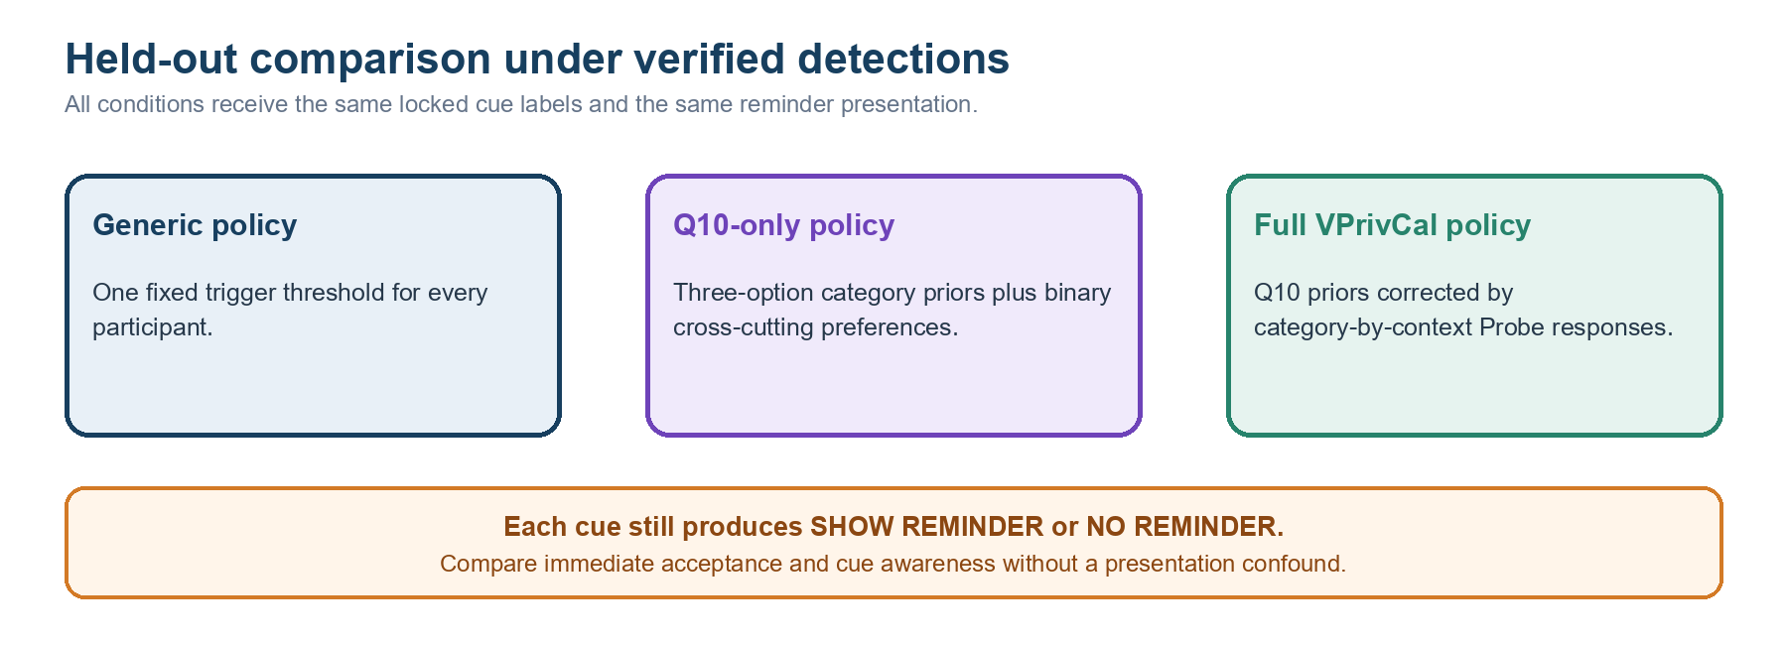
Figure 3. Policy conditions tested on held-out video cues.
Static calibration and dynamic evaluation remain intentionally different. Held-out clips use locked expert-verified detections and the same reminder presentation in every condition. Include both exposure labels when feasible so the middle trigger can be evaluated.
Design element | Recommendation
Participants | N = 80-120 for the main controlled study; use a smaller N = 12-20 usability pilot first.
Design | Within-subject comparison of generic, Q10-only, and full VPrivCal; clip-policy assignment counterbalanced.
Materials | 10-12 short clips with locked expert-verified cues; include both exposure levels where feasible.
Policies | Generic baseline, VPrivCal-Q10 only, and full VPrivCal.
Cue balance | Balance categories and PRESENCE_ONLY versus SENSITIVE_DETAIL_EXPOSED labels; avoid cells too small to interpret.
Controls | Exclude unresolved or disputed detections from the main effectiveness comparison.
Model output | Use one fixed VLM; two experts independently verify category and exposure level before locking the cue JSON.

7.1 Questions participants answer for each held-out cue
Construct | Question | Response
Expert verification gate | Do both experts confirm the cue and category? | Agree / adjudicated / excluded
Exposure label | Does the cue merely show category presence or expose identifying/sensitive details? | PRESENCE_ONLY / SENSITIVE_DETAIL_EXPOSED
Cue awareness | Before the reminder, had you noticed the privacy-relevant content? | Yes / partly / no
Preferred decision | Should the assistant have shown a reminder for this cue? | No reminder / show reminder
Decision acceptance | How acceptable was the assistant's reminder decision? | 1 Not at all - 5 Completely

Why detector verification is separate
The controlled study estimates the effect of VPrivCal under a locked verified cue set. The VLM candidate error rate and expert agreement must be reported separately from participant acceptance and awareness.

8. Outcomes and metrics
Metric | Operational definition | Role
Immediate acceptance | Mean cue-level acceptance and proportion rated 4-5. | Primary
Privacy-cue awareness | Unaided or pre-reminder awareness of the verified cue. | Primary
Binary decision alignment | System reminder decision equals the participant's preferred decision. | Primary
False-reminder rate | System reminds when the participant prefers no reminder. | Burden guardrail
Missed-reminder rate | System does not remind when the participant prefers a reminder. | Privacy guardrail
Exposure-stratified effect | Outcomes reported separately for both expert-confirmed exposure levels. | Construct check
Probe awareness profile | Already aware / interpretive gap / perceptual-capability gap / rejected cue. | Descriptive
Reminder frequency | Number and proportion of verified cues that trigger the standard reminder. | Dose measure
Calibration burden | Completion time, skipped items, changes, and perceived effort. | Feasibility
User-friendliness | Relevance, number/timing, interruption, control, and willingness to use. | Secondary

8.1 Post-policy user-friendliness items
- The reminders focused on privacy risks that were relevant to me.
- The number of reminders was appropriate.
- The reminders appeared at appropriate moments.
- The reminders interrupted the main task more than necessary.
- The system made me feel sufficiently protected.
- I felt in control of how the assistant handled privacy risks.
- I would use this reminder configuration in a real egocentric assistant.
Use a 7-point agreement scale for overall policy experience, while retaining the cue-level 1-5 acceptance item. Analyze acceptance, awareness, burden, protection/control, and adoption separately unless psychometric evidence supports a composite.

9. Statistical analysis
- Exact alignment: logistic mixed-effects model with policy condition as a fixed effect and participant, clip, and cue as random intercepts.
- Binary decision alignment: mixed-effects logistic model or participant-level paired comparison, with exposure level included as a prespecified factor.
- Over-reminding and under-protection: mixed-effects logistic models; pre-register full VPrivCal versus generic as the primary contrast.
- Subjective scales: paired or mixed-effects comparisons across policies; report confidence intervals and effect sizes.
- Category transfer: interactions between condition and privacy category, expert-confirmed exposure level, inference status, and temporal dependence.
- Robustness: exclude invalid cues, exclude unsure responses, vary severity threshold, and repeat analyses with weighted under-protection costs.

10. Pilot gates and expert screening criteria
Area | Minimum gate before main study
Q10 comprehension | At least 80% of cognitive-interview participants paraphrase each item consistently.
Q10 timing | Median <= 3 minutes; fewer than 5% skipped core items.
Probe timing | Median <= 5 minutes for the complete pointing and category-review phase; median total calibration time <= 7 minutes. Re-estimate after the usability pilot rather than assuming a three-minute total.
Stimulus distinctiveness | Experts and users distinguish the private, public, and semi-public settings and understand why the same category may appear in multiple scenes.
Category and evidence validity | At least 80% accept each listed category as present in its scene and each linked detection as valid supporting evidence; disputed items are revised or removed.
Pointing and mapping usability | At least 90% of intended selections are matched to a detection or successfully corrected through the manual-region/category controls; detections remain hidden before submission.
Safety | No unresolved critical issue involving bystanders, children, false sensitive inferences, or severe under-protection.

11. Ethics, data management, and limitations
- Use only synthetic or fully consented egocentric stimuli; never expose real identifiers or real sensitive records.
- Do not ask the model to infer actual protected traits about identifiable real people. Use synthetic cues and categorical descriptions.
- Allow participants to skip high-risk content and explain that the calibration cannot guarantee privacy.
- Store only de-identified responses; keep image/video files separate from participant identifiers.
- The three-scene Probe provides retrospective and interaction-based awareness evidence, but it still cannot establish spontaneous awareness during unconstrained natural use.
- The initial results generalize to egocentric assistance, not automatically to uploaded photos, screenshots, or social-media images.

12. Recommended execution sequence
Phase | Participants | Purpose
Expert screen | 6-10 experts | Review three-option wording, exposure codebook, cue agreement, safety floors, and study feasibility.
Cognitive interviews | 6-10 target users | Check interpretation of Q10, probe responses, and policy labels.
Usability pilot | 12-20 users | Measure timing, confusion, scene salience, and workflow failures.
Main evaluation | 80-120 users | Compare generic, Q10-only, and full VPrivCal on held-out videos.
External validation | Optional | Repeat on a new video set, user population, or VLM.

13. References
Tsaprazlis, E., Feng, T., Ramakrishna, A., Gupta, R., & Narayanan, S. (2025). Assessing Visual Privacy Risks in Multimodal AI: A Novel Taxonomy-Grounded Evaluation of Vision-Language Models. arXiv:2509.23827.
Orekondy, T., Schiele, B., & Fritz, M. (2017). Towards a Visual Privacy Advisor: Understanding and Predicting Privacy Risks in Images. ICCV.
Tomekce, B., Vero, M., Staab, R., & Vechev, M. (2025). Private Attribute Inference from Images with Vision-Language Models. NeurIPS.
Amershi, S., et al. (2019). Guidelines for Human-AI Interaction. CHI.
Terwee, C. B., et al. (2018). COSMIN methodology for evaluating content validity. Quality of Life Research, 27, 1159-1170.
Polit, D. F., Beck, C. T., & Owen, S. V. (2007). Is the CVI an acceptable indicator of content validity? Research in Nursing & Health, 30(4), 459-467.

